**Guidelines for Data Visualization and Analysis Project**

**About the Project:**

In this project, you will be working with a dataset from the Superstore, aiming to answer 30 scenario-based questions through data visualisation and analysis. Your objective is to select the best chart for each question, explain your choice. This project will showcase your proficiency in data visualisation, critical thinking, and effective communication.

**Skills Required:**

* Proficiency in data visualisation concepts and techniques.
* Familiarity with Tableau or a similar data visualisation tool.
* Strong analytical and problem-solving skills.
* Ability to choose appropriate charts based on data characteristics and question requirements.
* Clear and concise communication skills.

**Deliverables:**

* A Google document containing solutions to the scenario based questions including the screenshot of relevant chart picked for each scenario, presented in a concise and well-structured format. Make sure to provide explanations that highlight your problem-solving skills.

**Rubrics for Assessment:**

Question Responses:

* Accuracy and completeness of answers for all 30 questions.
* Clear and concise explanations that address the question's context.

Chart Selection and Explanation:

* Thoughtful rationale for choosing specific chart types.
* Justification based on data characteristics, context, and communication goals.

Creative Enhancements:

* Effective use of creative elements to enhance visualisation quality.
* Enhancements that contribute to better understanding or engagement.

**Note**:

* Duplicate this document and proceed to write your solutions.
* For each scenario and question, provide a justification for the choice of chart type. Explain why it is the best option to visualise the data effectively.
* Attach screenshots of the charts you have created in Tableau for each scenario and question using the Superstore dataset. Label them clearly to match the corresponding questions in the Google Document.
* Submit the duplicated google doc file after completion.

Use these guidelines to structure your data visualisation and analysis project. Remember to maintain consistency in your responses, explanations, and visualisation styles. This project will not only demonstrate your skills but also your ability to effectively communicate complex information through visualisations. Good luck!

**Problem Statement: Choose the Best chart for any 30 scenario based questions from Superstore Dataset.**

Imagine you are a data enthusiast aiming to excel in data visualisation and analysis. In this task, you have been given any 30 scenario-based questions derived from the Superstore dataset, and your objective is to provide insightful answers using appropriate charts. For each question, you need to select a chart that best represents the data, explain why you chose that specific chart, and then proceed to build the chosen chart using Tableau.

Your responses should be succinct, organised, and illustrative of your problem-solving capabilities.

**Dataset Link:**

<https://community.tableau.com/s/question/0D54T00000CWeX8SAL/sample-superstore-sales-excelxls>

**Please keep in mind:**

1. **Answer Completion**: Ensure that you furnish answers for all any 30 questions and build charts for them.
2. **Encouraged Creativity**: Don't hesitate to employ visuals, creative elements, or any other innovative approaches to enhance the quality of your responses.

By completing this task effectively, you'll not only demonstrate your proficiency in data visualisation and analysis but also showcase your ability to effectively communicate complex concepts through both text and charts.

**Good luck!**

**Questions:**

1. **Which product categories have the highest total sales in the "Superstore" dataset?**

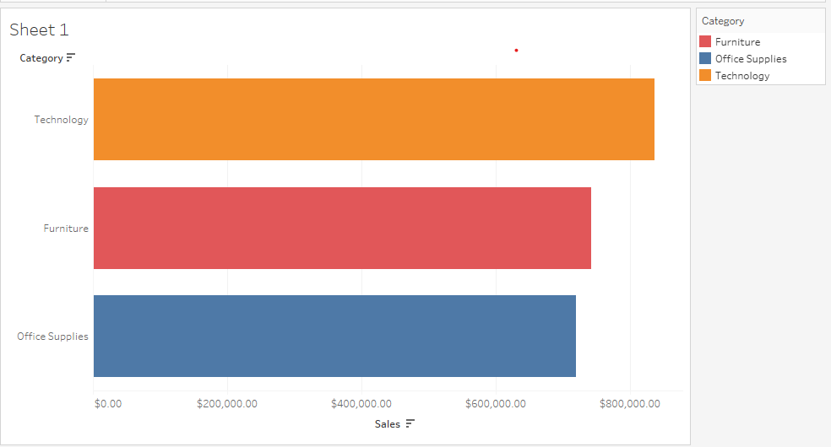

**Chart Type -** Bar Chart is used as we are trying to find the total sales (numerical variable) of product categories (categorical variable)

**Answer -** Products with category ‘technology’ have the highest total sales

1. **How do the monthly sales amounts change over the course of a year?**

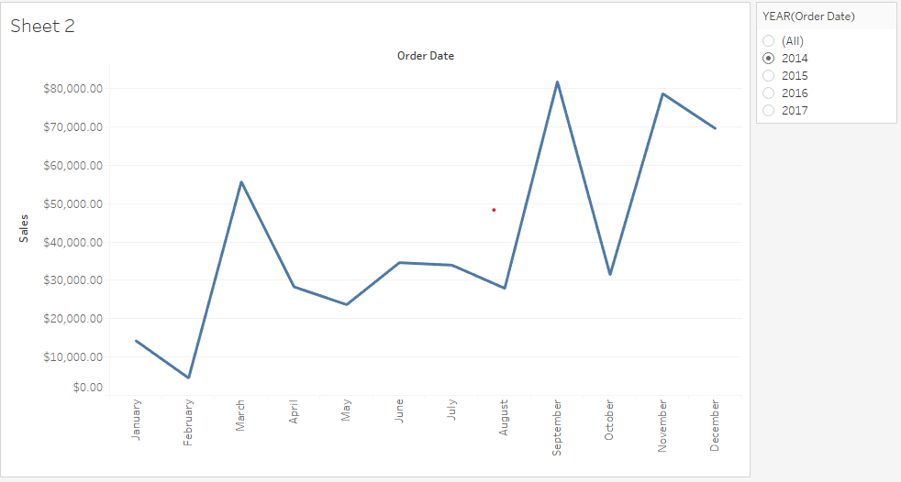

**Chart Type -** Line chart is chosen as we are trying to find the trends in monthly sales of products

**Answer -** We have used year filter to find monthly sales of any particular year. In this chart we used the year 2014. As we can see there is no clear pattern here . Sales sharply increases in months march, September and november otherwise it remains more or less constant in the middle months

1. **How is the total sales amount distributed among different product categories?**

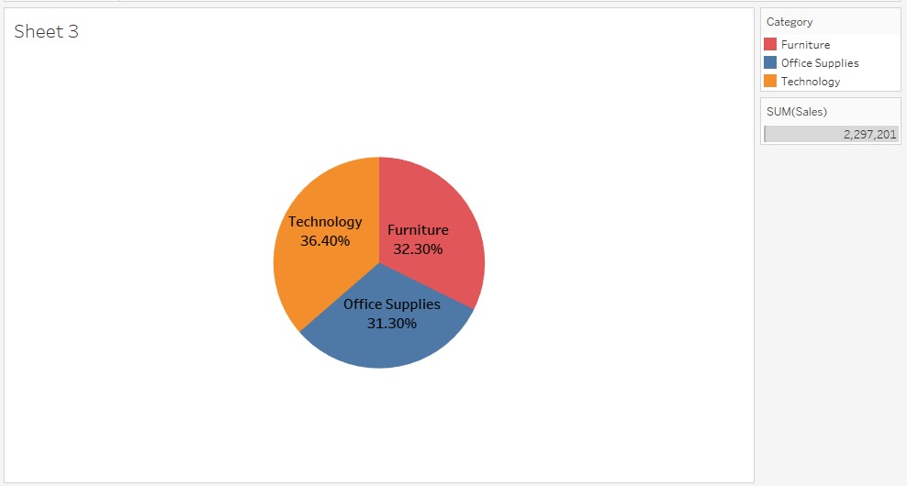

**Chart Type -** Pie chart is chosen to show percent sales distribution of different product categories

**Answer -** Here we can see that sales distribution is almost same for all categories with slight edge to technology products

1. **Can we analyze the sales performance of individual customers over time?**

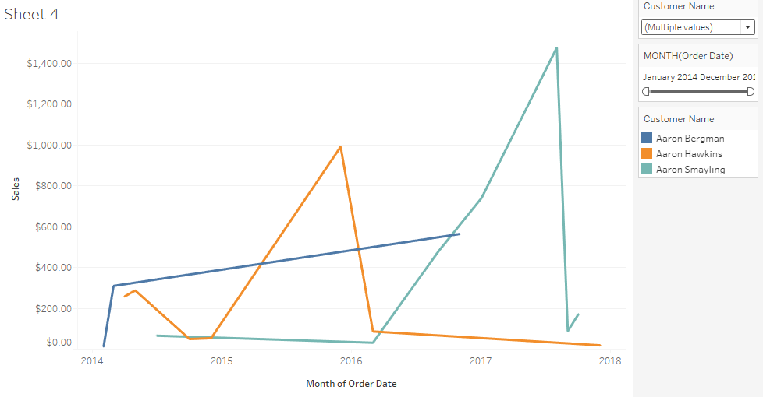

**Chart Type -** We have used line chart as we are analysing the trends of sales over time by individual customers

**Answer -** Here we have used two filters (order date and customer name). In this chart we find the sales performance of three customers. In the same way we can find the sales of other customers as well for a particular time period.

1. **How do sales vary based on different days of the week and product categories?**

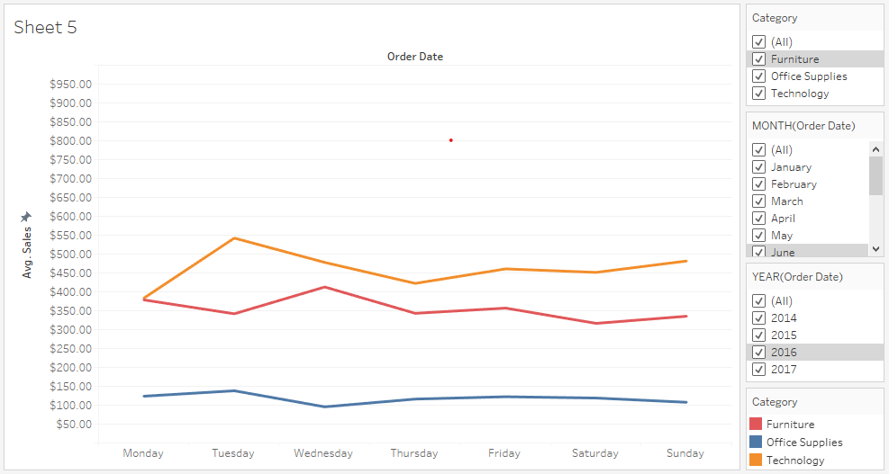

**Chart Type -** Line chart is chosen to visualize weekly trends in sales of different product categories

**Answer -** Here we used three filters(order date-month,order date-year and category). Through this chart we can find the average sales trends in different days of the week for different months,years and categories

1. **Can we visualise the sales growth of different product categories over time?**

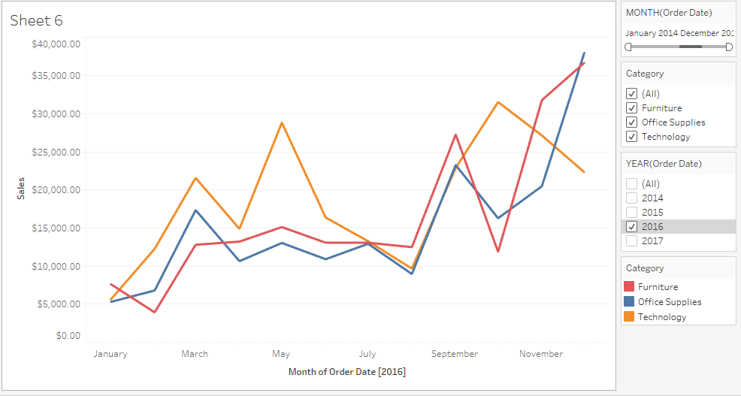

**Chart Type -** Line chart is chosen to show trends of sales growth over time

**Answer -** Here we used three filters(order date month, order date year and categories). We can find the sales growth of a particular category for a particular time period

1. **How does the sales distribution vary across different regions in the "Superstore" dataset?**

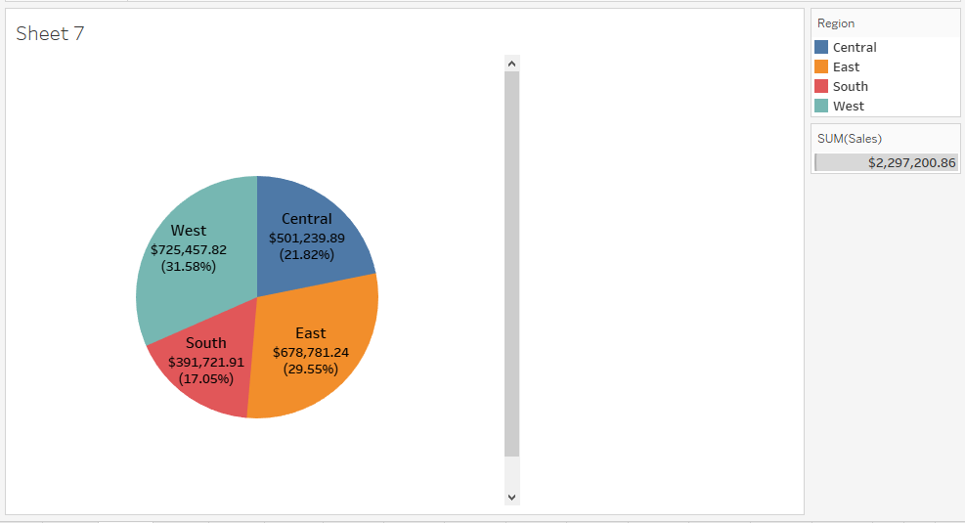

**Chart Type -** Pie chart is chosen to show the distribution of sales across regions both as a percentage of whole as well as in absolute values

**Answer -** Here we can see that west region has the highest sales with absolute value $725,457.82 and 31.58% of total sales

1. **Can we visualise the composition of profits across various subcategories within different customer segments?**

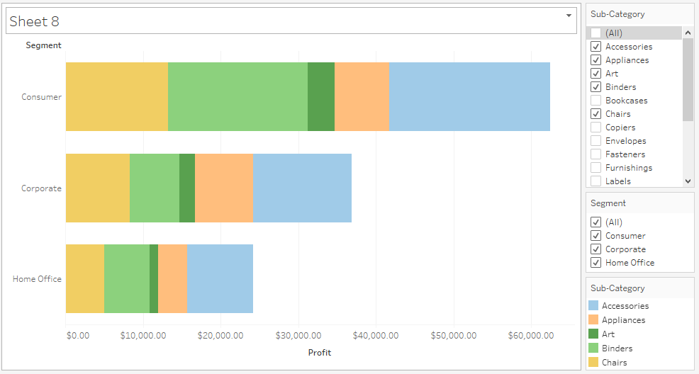

**Chart Type -** Bar chart is chosen to show the profits of each segment and then dividing each bar into various subcategories to answer the question

**Answer -** Here we created two filters - subcategory and segment. Through manipulating these filters we can find the profits associated with different subcategories within different segments

1. **What is the percentage contribution of each region to the overall sales?**

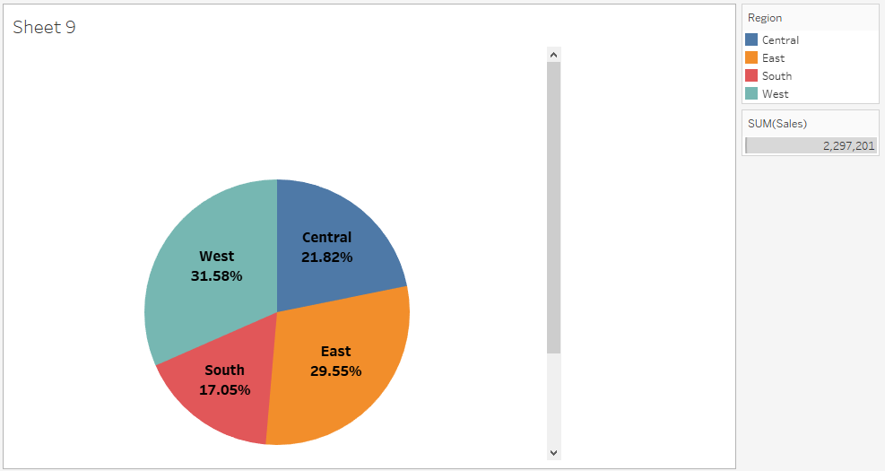

**Chart Type -** Pie chart is chosen as it is the most appropriate way to show percentage of whole amount

**Answer -** West has the highest contribution to sales

1. **Can we visualise the profit margins associated with different shipping modes and customer segments?**

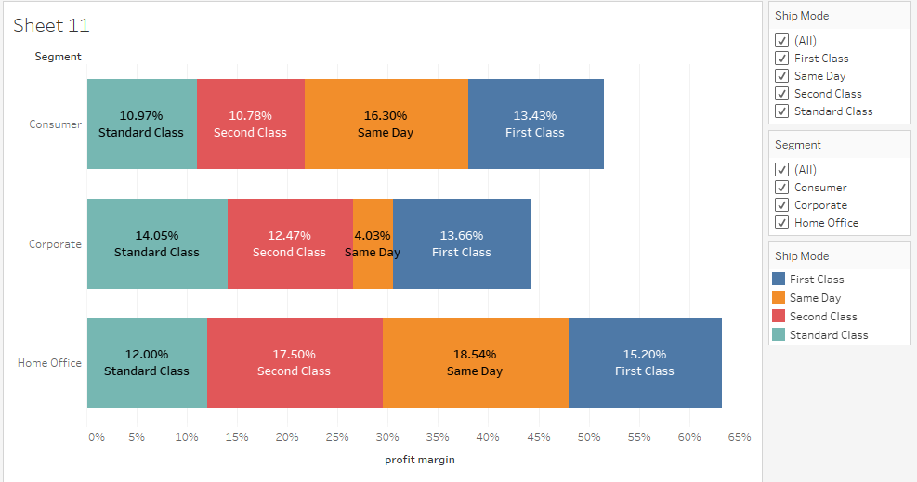

**Chart Type -** Bar chart is chosen to divide the each customer segment into different shipping modes and finding out the profit margin associated with each shipping mode within a segment

**Answer -** Here we created a separate measure ‘profit margin’ by dividing the total profit with total sales. Through this measure we found out the profit margin associated with each shipping mode within a customer segment

1. **How long does it take to process orders for different product categories?**

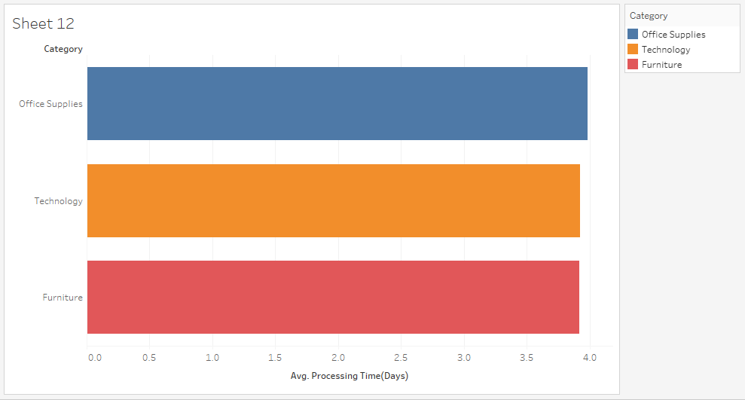

**Chart Type -** Bar chart is chosen to plot a categorical variable(category) with numerical variable(processing time)

**Answer -** Here we created a separate field ‘processing time’ by finding the days between order date and shipping date. In the chart we can see all three categories have almost same processing time with slight edge to office supplies

1. **How does the performance of different salespeople compare in terms of sales targets, actual sales, and profitability?**

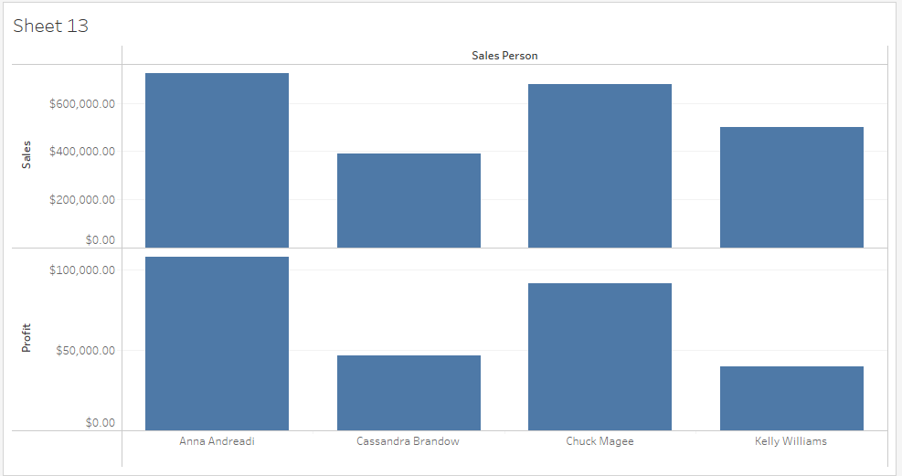

**Chart Type -** Bar chart is chosen to compare the sales and profits done by different people

**Answer -** Anna Andreadi had done most sales and profits

1. **Can we visualise the relationship between product sales and profitability for different product categories?**

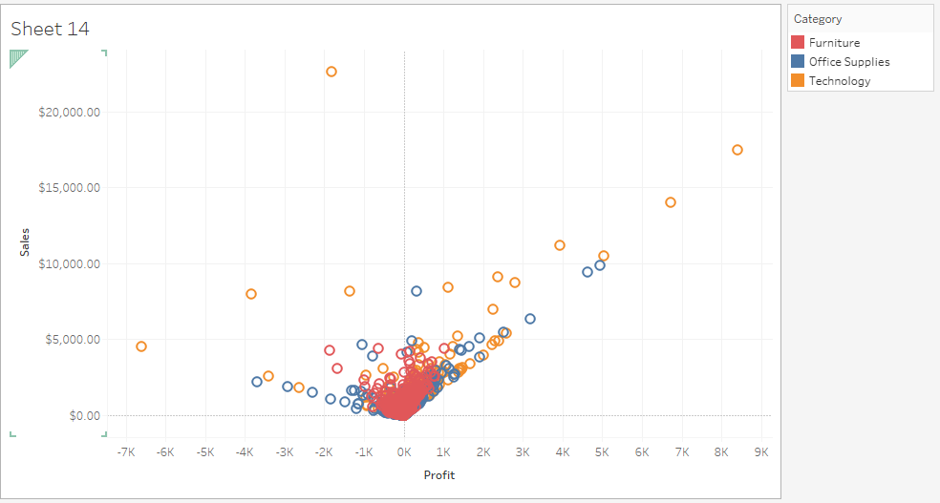

**Chart Type -** Scatter plot is chosen to visualise the relationship between two numerical variables(sales and profit)

**Answer -** Giving different colors to different product categories we can analyse the relationship between sales and profits for the categories.

1. **What is the distribution of order quantities for products in the dataset?**

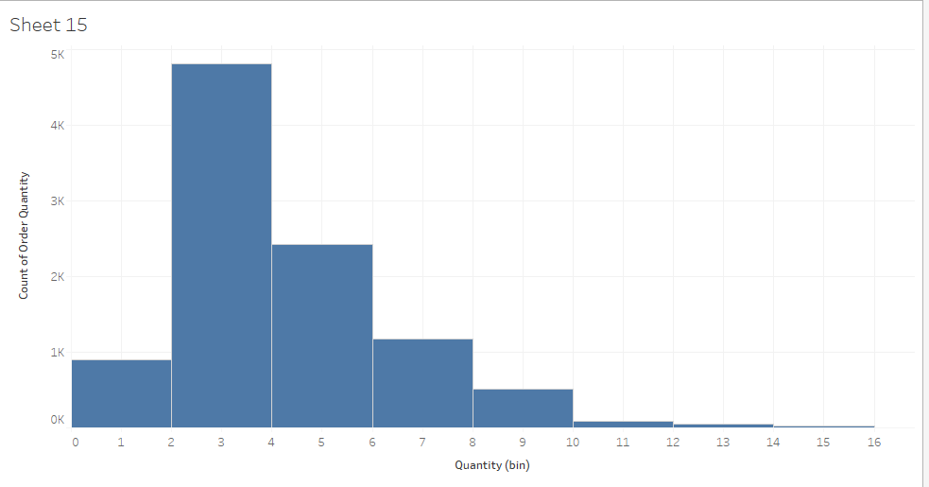

**Chart Type -** Histogram is chosen to show count of orders in different quantity intervals

**Answer -** Order quantities between 2 and 4 is most popular among customers

1. **How do the profit distributions vary across different product categories?**

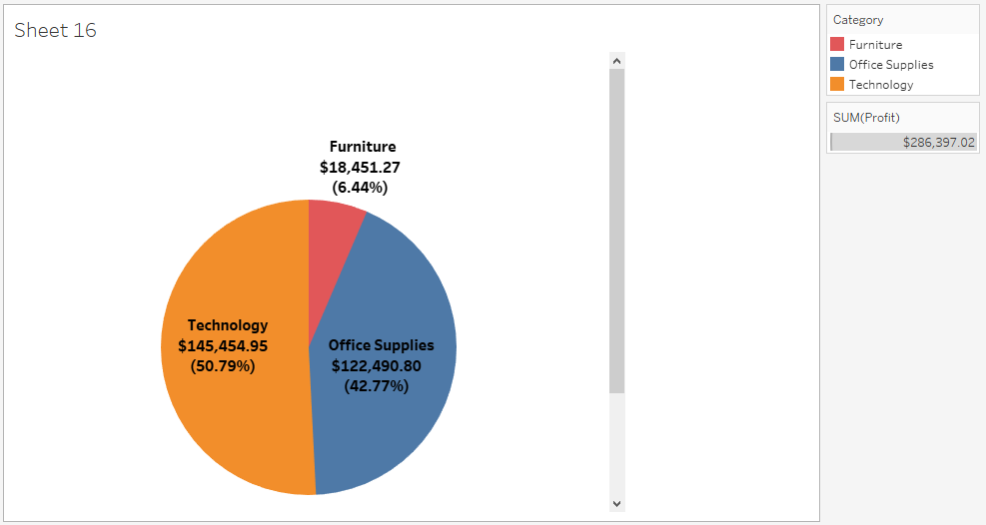

**Chart Type -** Pie chart is chosen to show profit percent of whole for different product categories

**Answer -** Technology products gave the most profit with contribution of 50.79%.

1. **Can we compare the shipping time distributions for different shipping modes?**

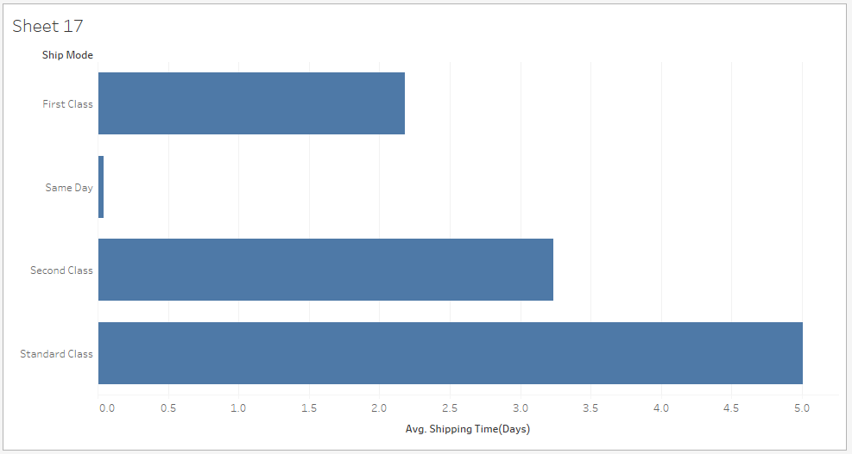

**Chart Type -** Bar chart is chosen to plot a categorical variable (ship mode) with a numerical variable(shipping time)

**Answer -** Standard class mode has the highest shipping time whereas same day mode has the lowest

1. **What is the monthly trend in the number of orders shipped?**

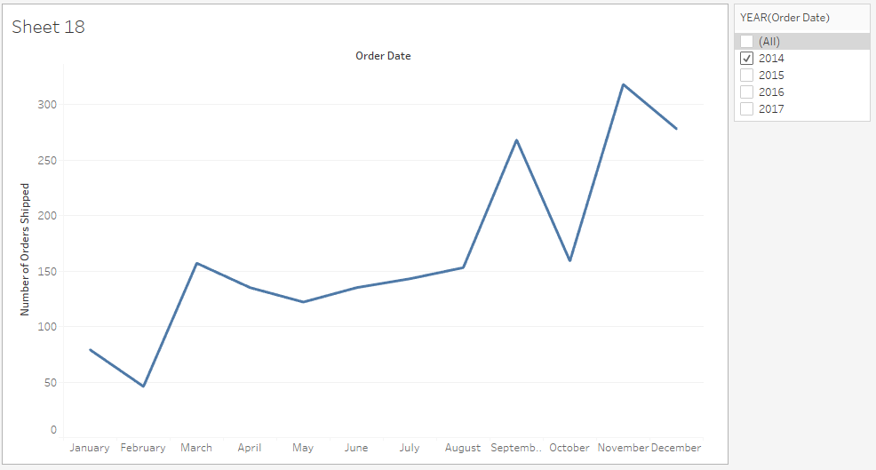

**Chart Type -** Line chart is chosen to show number of order trends monthly

**Answer -** Sales gradually increases from January to December

1. **How do different customer segments perform in terms of sales and discount rates?**

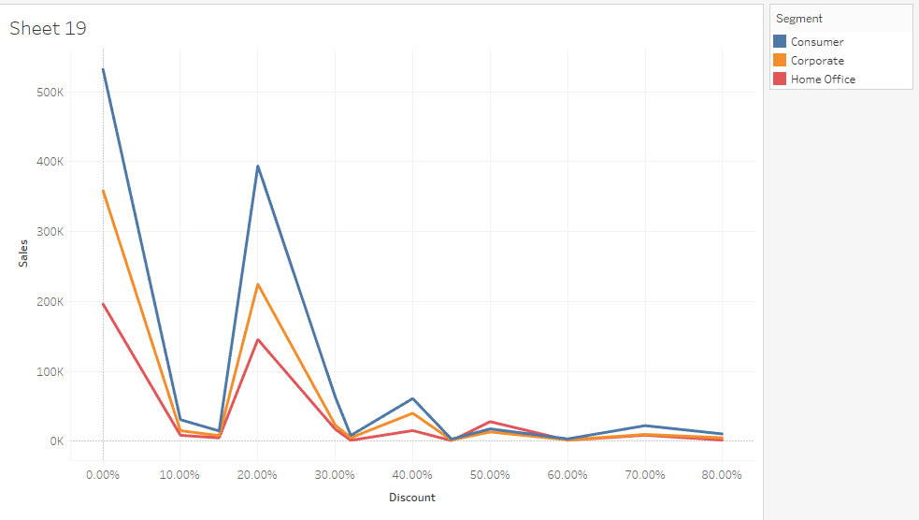

**Chart Type -** Line chart is chosen to show variation of sales with discount for different segments

**Answer -** Consumer segment has more sales and profits as compared to other segments

1. **How efficiently are different product subcategories being fulfilled in terms of order processing time and on-time delivery?**

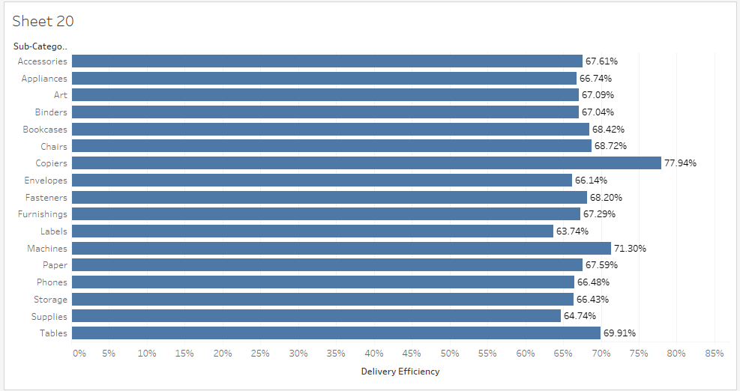

**Chart Type -** Bar chart is chosen to visualise values of a categorical variable(Sub category)

**Answer -** Delivery efficiency indicates the percent of on time deliveries. Chairs have the highest efficiency in terms of delivery

1. **What is the average delivery duration for different regions and ship modes?**

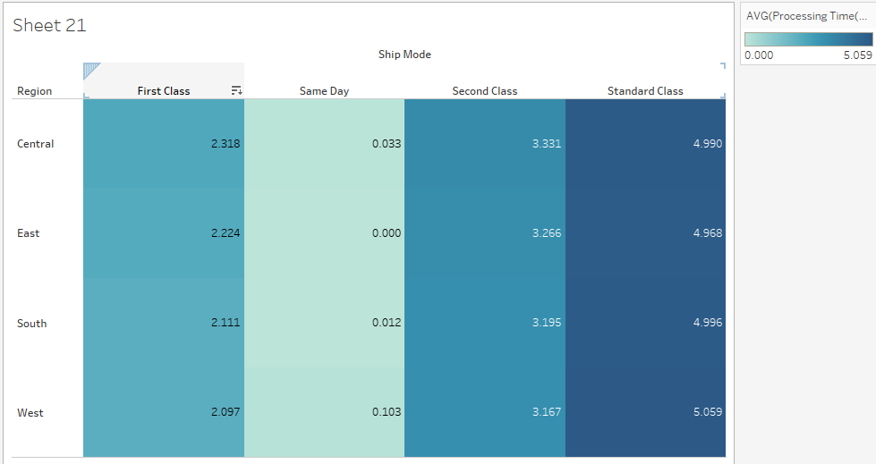

**Chart Type -** Heatmap is chosen to highlight range of delivery duration in terms of different colours

**Answer -** Standard class in western region has the highest average delivery duration

1. **How has the average order quantity changed over the years for various product categories?**

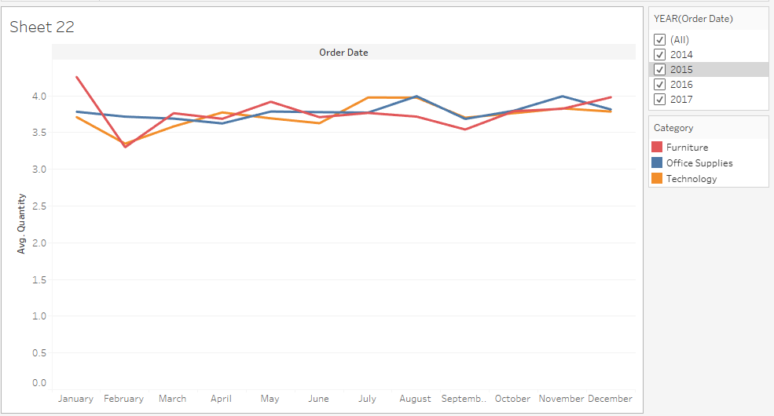

**Chart Type -** Line chart is chosen to show trends over time

**Answer -** Year filter is created to show trends for different years separately

1. **Can we visualise the correlation between discount rates and order quantities for different customer segments?**

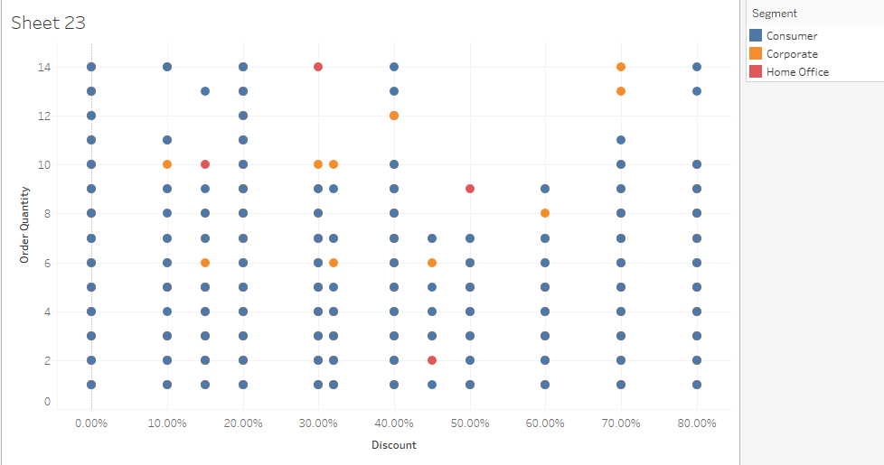

**Chart Type -** Scatter plot is chosen to visualise relation between two numerical variables

**Answer -** Most of the discount rates are applicable to consumer segment

1. **What is the trend of returns and refunds across different regions and product categories?**

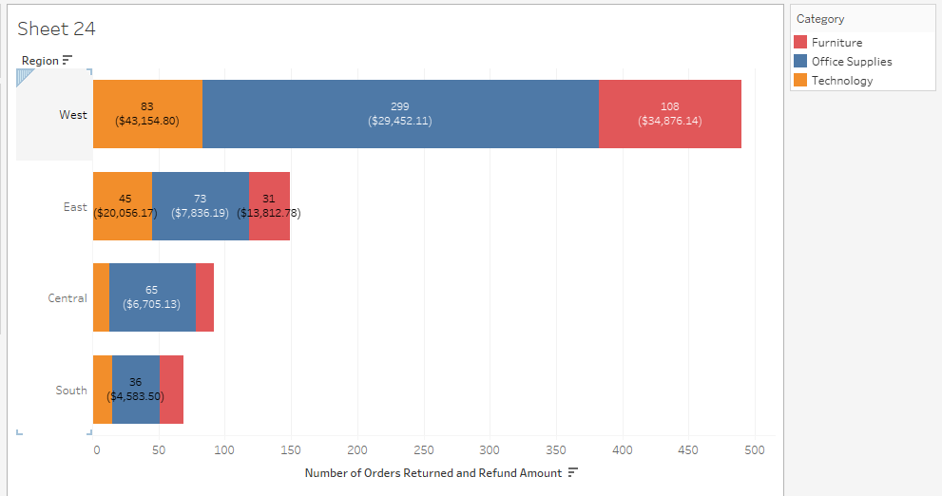

**Chart Type -** Stacked bar chart is chosen to show value of total orders returned and total refund amount for each category in a region(categorical variable)

**Answer -** West region has the most amount of returns.

1. **How do the sales of high-profit products compare with low-profit products over time?**

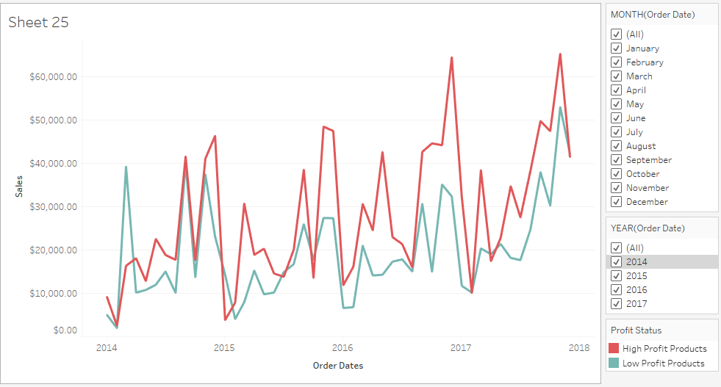

**Chart Type -** Line chart is chosen to show trends over time

**Answer -** A new field is created to show whether an order is of high profit or low profit products.From the graph it can be seen that high profit products have higher sales than low profit products

1. **Which shipping mode is the most commonly used in the Sample Superstore dataset?**

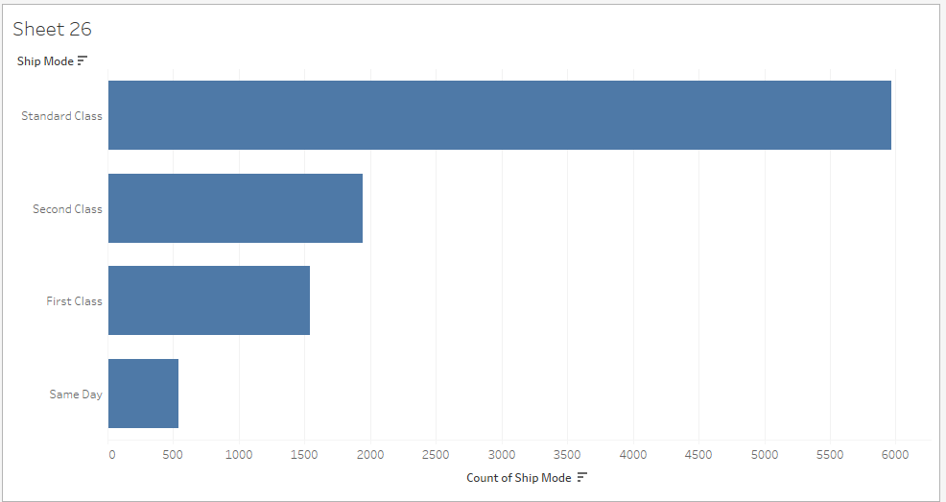

**Chart Type -** Bar chart is chosen to show value of a categorical variable(ship mode)

**Answer -** Standard class is most chosen shipping mode

1. **How does the sales performance of different regions evolve throughout the quarters of a year?**

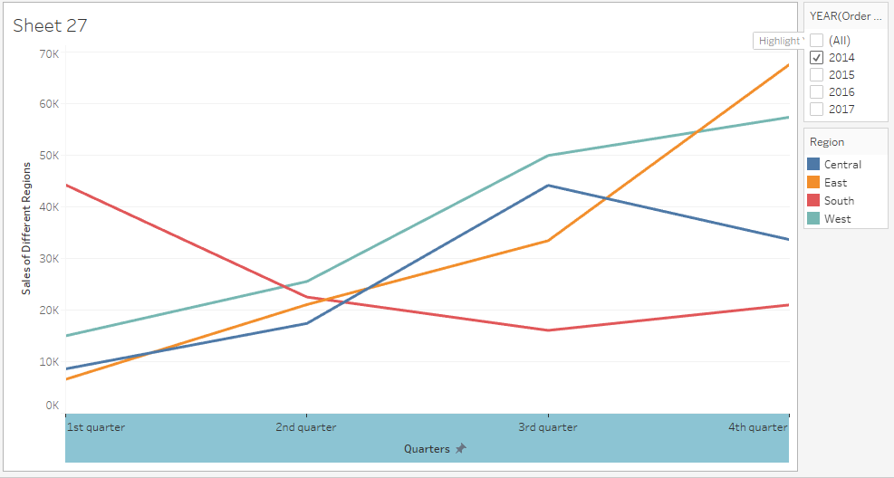

**Chart Type -** Line chart is chosen show sales trends over different quarters

**Answer -**West and East regions have increasing sales over different quarters in year 2014

1. **What is the distribution of order priorities across different product categories?**

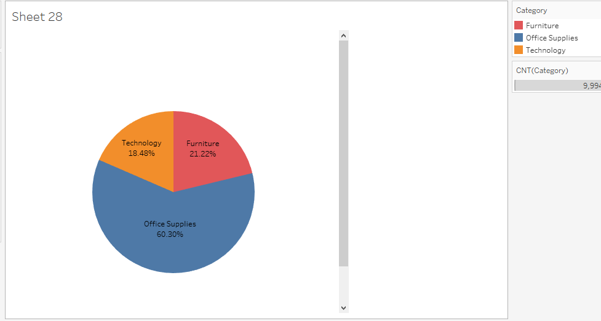

**Chart Type -** Pie chart is chosen to show percent preference of customers for different categories of products

**Answer -** Office supplies have highest preference among customers

1. **What is the relationship between discounts and sales?**

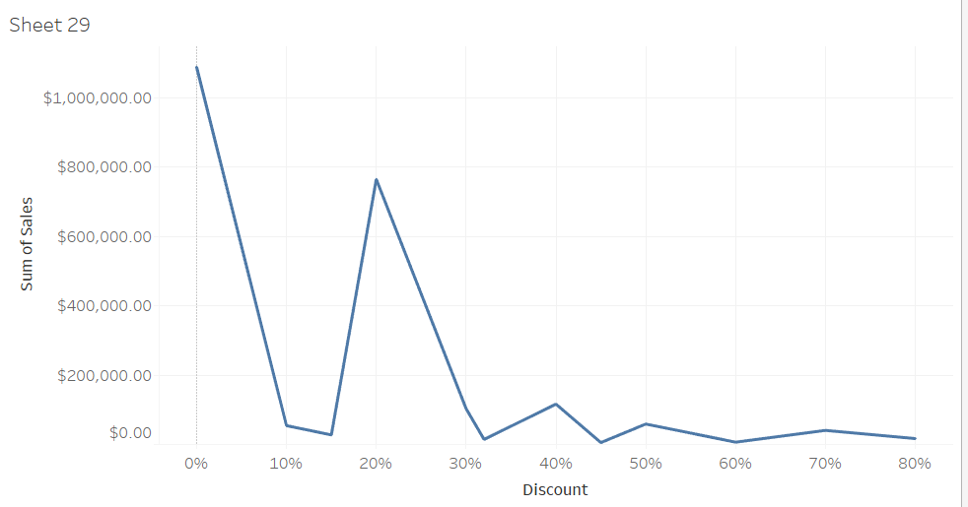

**Chart Type -** Line chart is chosen to show trends of sales among different discount values

**Answer -** Most sales have no discount

1. **How does the average order value differ between repeat customers and new customers?**

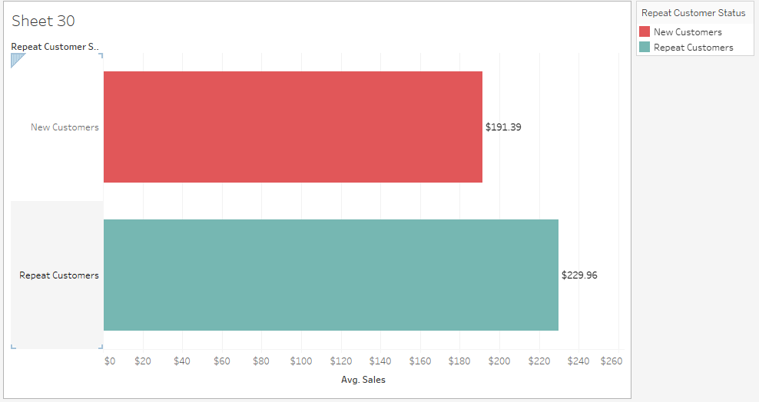

**Chart Type -** Bar chart is chosen to show average sales amount for a categorical variable(repeat customer status)

**Answer -** Repeat customers have more average sales amount than new customers

1. **What is the geographical distribution of returns and its impact on overall profitability?**

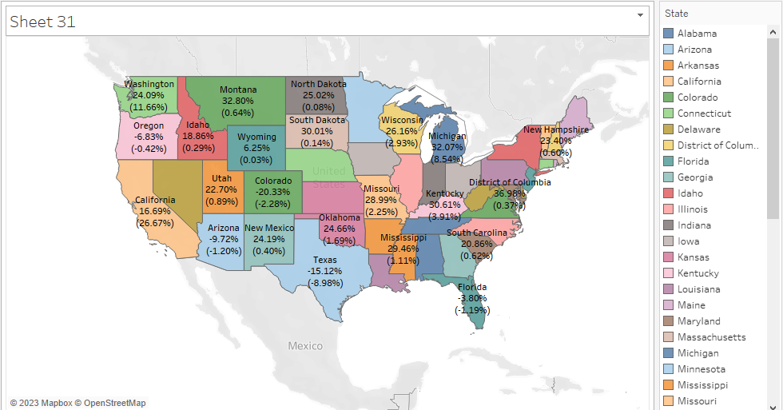

**Chart Type -** Geographical distribution can be best represented through maps where each state is labelled withreturns from its territory and contribution to overall profitability

**Answer -** States like Michigan and Mississippi have high returns on sales whereas states like california contributes most to overall profitability